**Experiment No : 06**

**Experiment Name :** Implementation of FCFS algorithm .

**Objective:**

FCFS stands for First Come First Serve Algorithm..We know about the algorithm and Implement it in C/C++ programming Language .

**Source Code :**

#include<stdio.h>

int main()

{ int n,bt[20],wt[20],tat[20],avwt=0,avtat=0,i,j;

printf("Enter total number of processes:");

scanf("%d",&n);

printf("\nEnter Burst Time of each process \n");

for(i=0; i<n; i++)

{

printf("P[%d]:",i+1);

scanf("%d",&bt[i]);

} wt[0]=0;

for(i=1; i<n; i++)

{

wt[i]=0;

for(j=0; j<i; j++)

wt[i]+=bt[j];

}

printf("\nProcess\t\tBurst Time\tWaiting Time\tTurnaround Time");

for(i=0; i<n; i++)

{

tat[i]=bt[i]+wt[i];

avwt+=wt[i];

avtat+=tat[i];

printf("\nP[%d]\t\t%d\t\t%d\t\t%d",i+1,bt[i],wt[i],tat[i]);

}

avwt/=i;

avtat/=i;

printf("\n\nAverage Waiting Time:%d",avwt);

printf("\nAverage Turnaround Time:%d",avtat);

return 0;

}

**Output :**

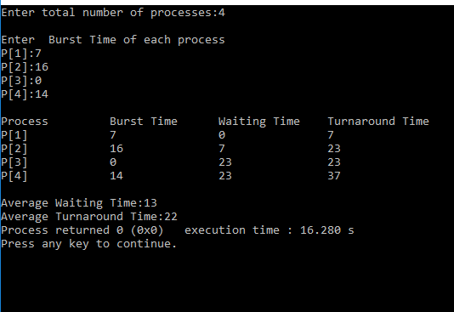

**Conclusion :**

FCFS is the simplest scheduling algorithm. FIFO simply queues processes in the order that they arrive in the ready queue.So it is Very Important Algorithm to know and execute in Further .

.